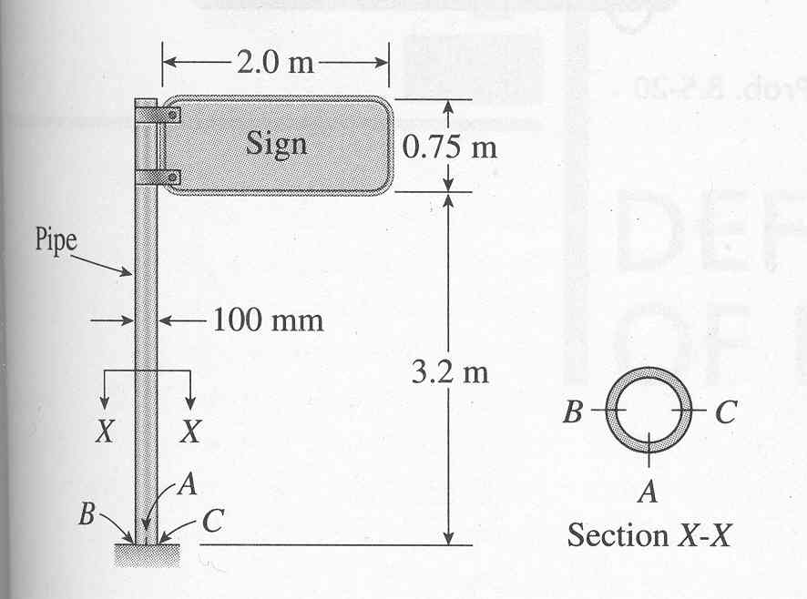A sign is supported by a pipe having outer diameter 100mm and inner diameter 80mm. The dimensions of the sign are 2.0m x 0.75m, and its lower edge is 3.2m above the base. The wind pressure against the sign is 1.8 kPa. Determine the maximum in-plane shear stress due to the wind pressure on the sign at points A, B, and C, located on the outer surface at the base of the pipe.

Problem from Gere & Timoshenko, “Mechanics of Materials,” 4th, Problem 8.5-16.